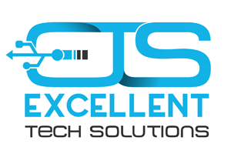

Excellent Tech Solutions

1240 Commerce Dr., Gulf Shores, AL 36542

Office phone #: 251-929-9404

All the IT Support your business needs and more.

Services:

* Hardware installation, maintenance and repair
  + New equipment setup
  + Regular maintenance of currently operating systems
  + Computer and near computer equipment repair
* Software installation and support
  + Software installation and configure
  + Regular updates
  + License renewal
* Telephony / VoIP
  + Business phone system solutions
  + Flexible business communication
  + Wide range of features available
* Cabling and wiring
  + Cable installation
  + Wire concealment
* Network design, setup, maintenance and troubleshoot
* Help Desk
  + User support
  + Tutoring
* Data backup and disaster recovery
  + Setup local backup or cloud backup
  + Verify backups
* Mobile device support and repair.
  + Hardware and software repair
* Audio/Video systems design, installation and maintenance
  + Small to large custom audio systems
  + Home entertainment
  + Meeting rooms
* Video surveillance systems installation and maintenance
  + Professional security surveillance systems deployment
  + Remote access setup
  + Two-way audio
  + 24/7 or motion recording
* Smart appliance integration
  + Voice assistant setup
  + “Smart” lights, thermostat, garage door etc.
* Graphic Design and Print Media
  + Logo design
  + Business cards design and print
  + Brochures, flyers, banners, door hangers and more